CS 255 System Design Document Template

UML Diagrams

UML Use Case Diagram
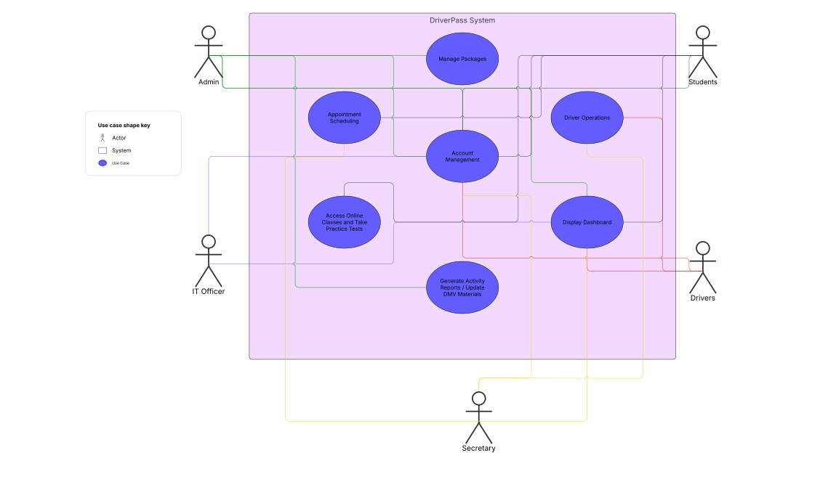

UML Activity Diagrams
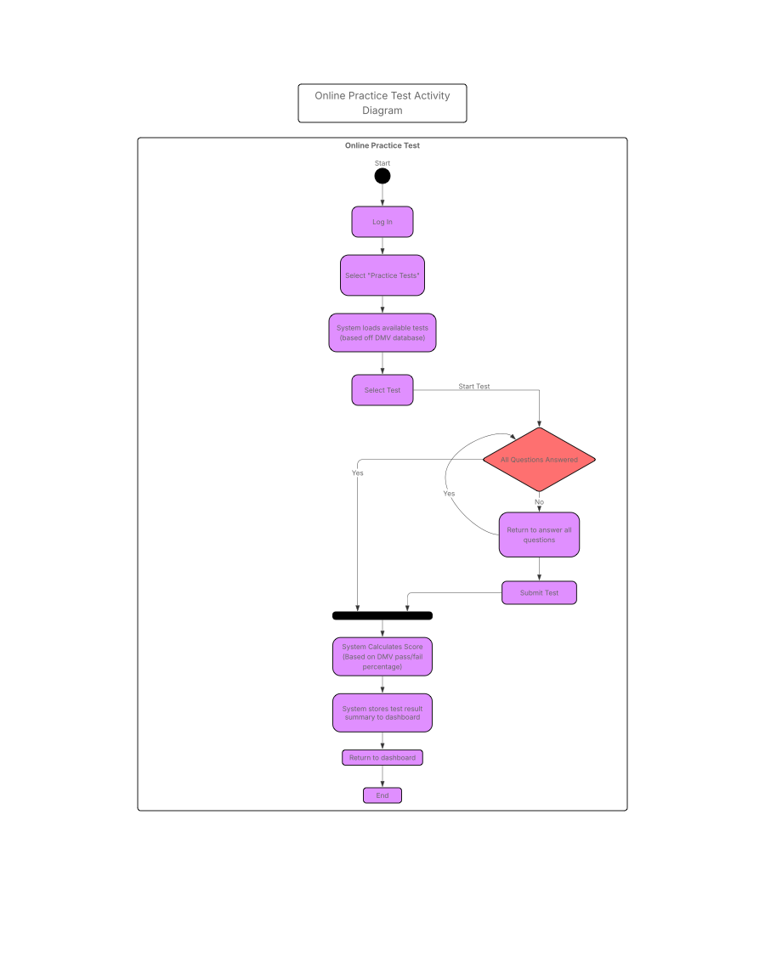

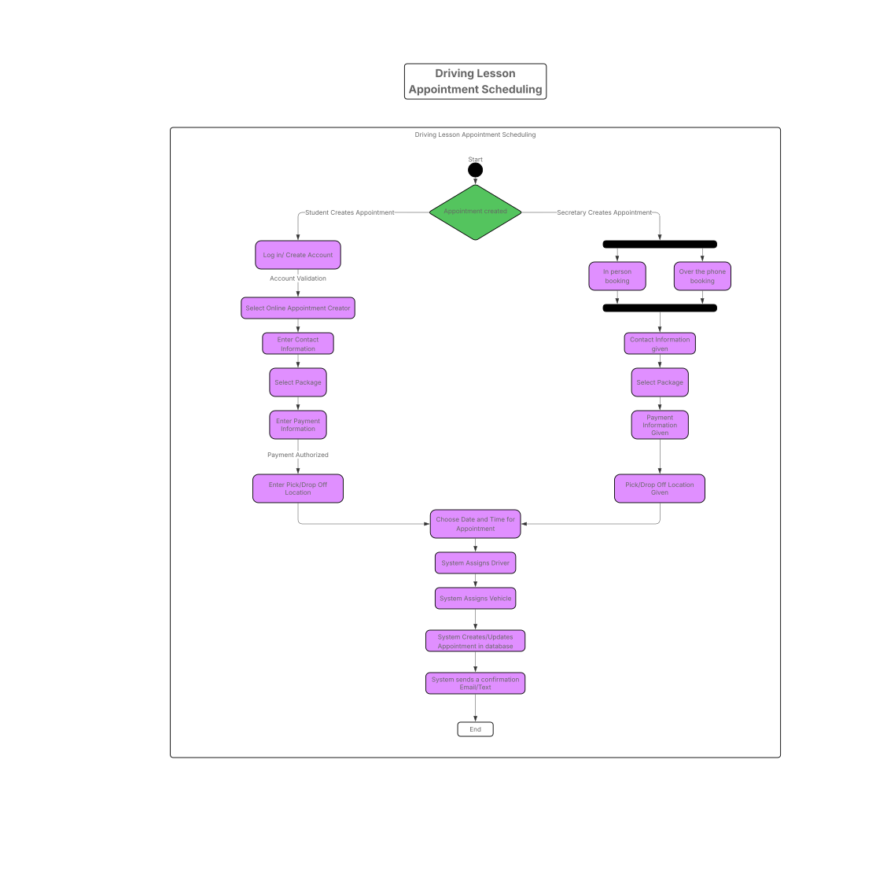

UML Sequence Diagram
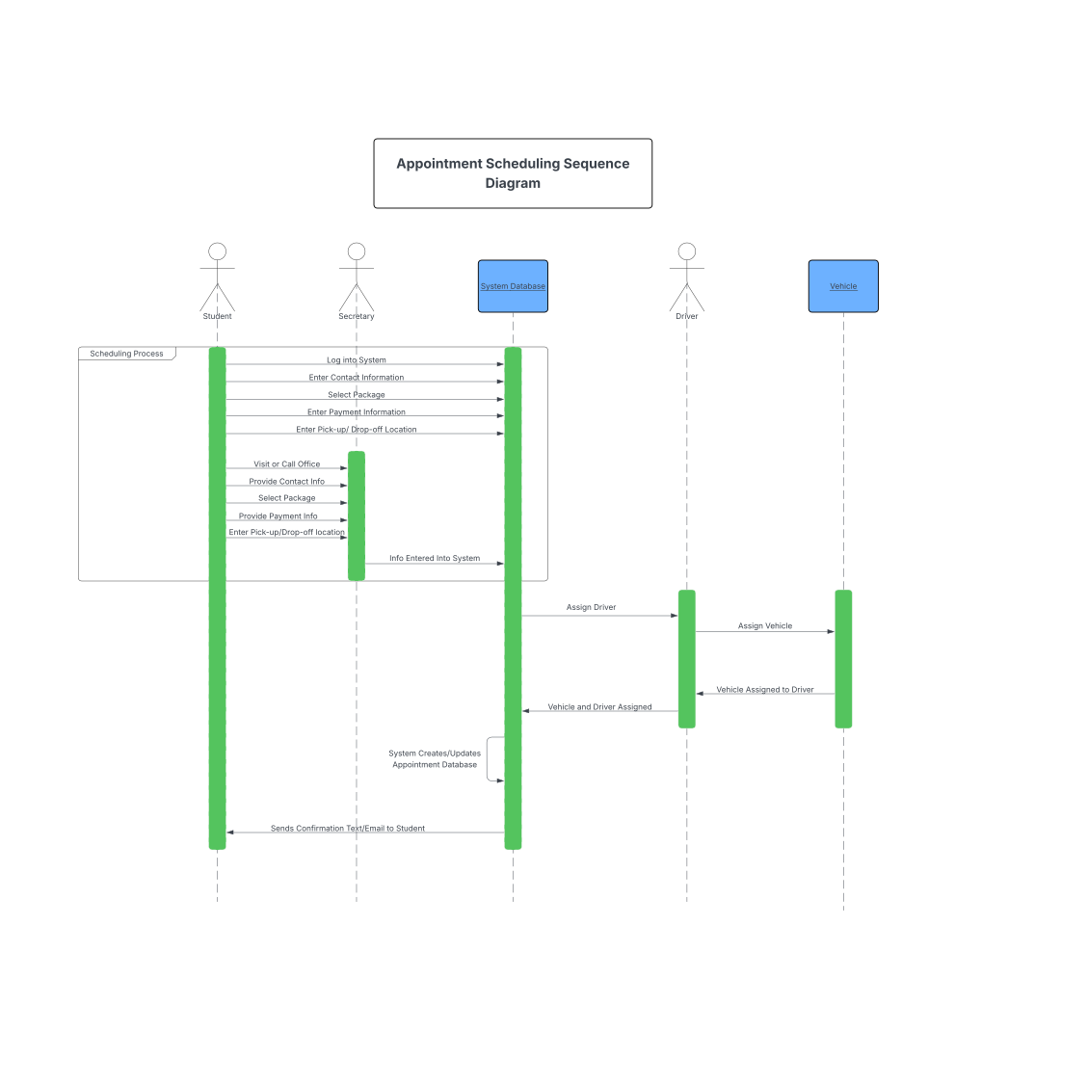

UML Class Diagram
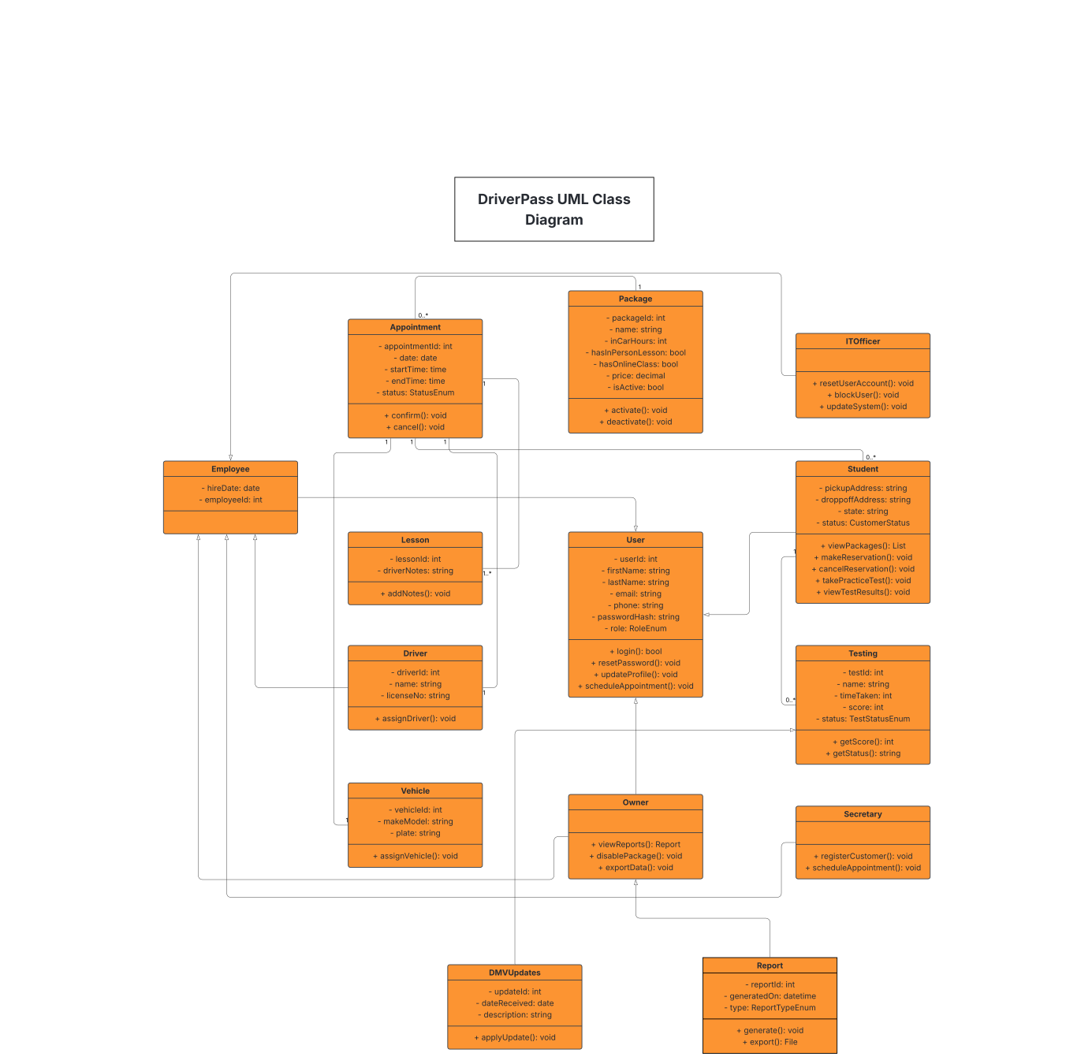

Technical Requirements

The DriverPass system has some basic technical requirements to be able to run properly based on UML diagrams created for the system. Starting off the system would need client-side and server-side components to be able to run on a cloud-based platform that is accessible from most web browsers on desktop or from mobile devices. Using database systems like MySQL or PostgreSQL is preferable to store and maintain user data, reservations, tests, and package information. To build the server-side portion of the system frameworks like Node.js or Django would be used for authentication, access control, and API services. For the front end and interface of the system frameworks like React and Angular would be used. Other tools that need to be considered are payment gateway for services like PayPal to process transactions securely. As well as platforms like AWS, Azure, or Google Cloud for secure hosting, daily backups, and scalability. Finally, the infrastructure must support integration with DMV data services to receive updates to test content and compliance rules.

